**Nursery, Reception and Year 1**

**Phonics Guidance**

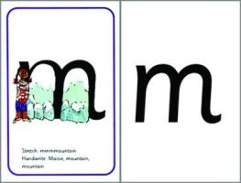

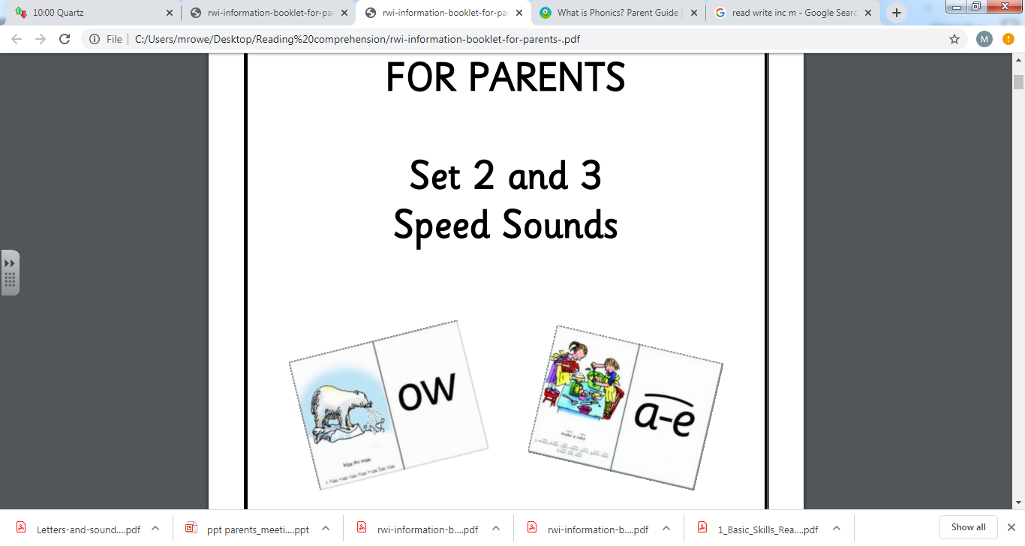

The information in this booklet will explain the phonics teaching that your son / daughter will receive daily at school during their time at Canon Popham C of E Primary Academy.

It also provides information on how you can help support your son’s / daughter’s phonics development at home.

If you need clarification or would like to know more about our phonics teaching, please make an appointment to speak to your son’s /daughter’s class teacher.

Thank you for your continued support.

The information written in this pamphlet has been gathered from a variety of sources, including:

[www.oxfordowl.co.uk](http://www.oxfordowl.co.uk)

[www.oup.com/oxed/primary/rwi/forparents/](http://www.oup.com/oxed/primary/rwi/forparents/)

Read Write Inc. Phonics: Home More Phonics Flashcards

**Phonics - Nursery**

In Nursery, our focus is to develop children’s phonological awareness so that they can

spot and suggest rhymes, segment and blend words orally, as well as to recognise words with

the same initial sound such as money and mother.

Teachers are encouraged to re-visit and provide opportunities for children to explore these skills in continuous provision.

**Phonics – Reception and Year 1**

**What is phonics?**

Phonics is a method of teaching children to read. Phonics works by breaking words down into individual sounds. Each one of the 26 letters of the alphabet has its own ‘sound’, however, there are 44 different sounds in total in the English language. Some of these sounds are made up of 2 or 3 letters. At Canon Popham we follow the Read, Write, Inc programme to deliver our phonics teaching.

Before your son/ daughter can start to read, s/he needs to learn to:

• say the sound that is represented by each letter or groups of letters

• sound out the word, e.g. c-a-t, sh-o-p, s-t-r-ee-t

• blend the sounds back together to say the word e.g. c-a-t, cat.

**Phonics vocabulary**

**Phoneme –** a sound as it is said when you see the letter

**Grapheme –** a sound that is written

**Digraph –** two letters that work together to make the same sound

**Trigraph -** three letters that work together to make the same sound

**Split digraph -** two letters that work together to make the same sound, separated by

another letter

**Fred talk –** Fred is a puppet who says, reads and spells words in pure sounds; he never say

the whole word so the children do this for him

**Green words –** Words made up of graphemes that children have been taught.

**Red words –** Common words with an uncommon spelling e.g. go, the, you

**Syllables –** Chunks within long words e.g. mid / night = midnight

**Root –** The part of the word that gives most meaning e.g. fast / faster

**What are speed sounds?**

In Read Write Inc phonics the individual sounds are called ‘speed sounds’ – because we want your son/daughter to read them effortlessly.

**What are ‘speed sounds’ Set 1, Set 2 and Set 3?**

**Set 1** In Reception your son/daughter learns to recognise and say the sounds of the 26 letters of the alphabet and the first few digraphs, below by sight. They also learn how to blend them together to read words e.g. c-a-t cat.

m, a, s, d, t, i, n, p, g, o, c, k, u, b, f, e, l, h, sh, r, j, v, y, w, th, z, ch, qu, x, ng, nk

**Set 2** (The long vowel sounds.) In Reception your son/daughter will progress to learning their Set 2 sounds in the Spring Term.

There are 12 Set 2 ‘speed sounds’ that are made up of two or three letters which represent just one sound, e.g. ay as in play, ee as in tree and igh as in high. It is important that your son/daughter does not pronounce these as 2 or 3 separate sounds. When your son/daughter sees the ‘speed sound’ letters together in a word, s/he must say just one sound for these letters. For example in the word tree, we say t-r-ee not t-r-e-e.

When your son/daughter learns their Set 2 sounds in school they will learn:

* the letters that represent a speed sound e.g. ay
* a simple picture prompt linked to the ‘speed sound’ and a short phrase to say e.g. may I play

Every speed sound has a list of green words linked to it, so your son/daughter can ‘sound out’ and ‘sound blend’ words containing the new speed sound they have just learnt, for example:

s-p-r-ay spray.

|  |
| --- |
| **ay**: may I play |
| **ee**: what can you see |
| **igh**: fly high |
| **ow**: blow the snow |
| **oo**: poo at the zoo |
| **oo**: look at a book |
| **ar**: start the car |
| **or**: shut the door |
| **air**: that’s not fair |
| **ir**: whirl and twirl |
| **ou**: shout it out |
| **oy**: toy for a boy |

**Set 3** Your son/daughter will have learnt one way in which each long vowel sound is written when they completed the Set 2 sounds. In Year1 your son/daughter will learn their Set 3 speed sounds, where they will be taught that there are more ways in which the same sounds are written, e.g. *ee* as in tr*ee* and *ea* as in t*ea*. It takes some time for this information to be fully understood by your son/daughter.

There are 20 Set 3 ‘speed sounds’ that are made up of two or three letters which represent just one sound, e.g. *ea* as in t*ea*, *ow* as in c*ow* and *are* as in c*are*. As before, it is important that your son/daughter does not pronounce these as 2 or 3 separate sounds. When your son/daughter sees the ‘speed sound’ letters together in a word, s/he must say just one sound for these letters.

When your son/daughter learns their Set 3 sounds in school they will learn:

• the letters that represent a speed sounds e.g. *ea*

• a simple picture prompt linked to the ‘speed sound’ and a short phrase to say e.g. *cup of tea*

Every speed sound has a list of green words linked to it, so your son/daughter can ‘sound out’ and ‘sound blend’ words containing the new speed sound they have just learnt, for example: s-p-oi-l spoil.

|  |
| --- |
| **ea**: cup of tea |
| **oi**: spoil the boy |
| **a-e**: make a cake |
| **e-e:** Pete and Steve |
| **i-e**: nice smile |
| **o-e**: phone home |
| **u-e**: huge brute |
| **aw**: yawn at dawn |
| **are**: share and care |
| **ur**: purse for a nurse |
| **er**: a better letter |
| **ow**: brown cow |
| **ai**: snail in the rain |
| **oa**: goat in a boat |
| **ew**: chew the stew |
| **ie:** terrible tie |
| **au:** Paul the astronaut |
| **ue:** Come to the rescue |
| **wh:** whisk, whisk |
| **ph:** take a photo |
| **ire**: fire fire! |
| **ear**: hear with your ear |
| **ure**: sure it’s pure? |
| **tion**: celebration |
| **tious** / **cious**: (scrumptious / delicious |
| **e**: he me we she be |

**What are green words?**

‘Green words’ are words which your son/daughter will be able to ‘go ahead’ and read as they are made up of the speed sounds that s/he will have learnt.

**Resources for home use**

Read Write Inc. Phonics: Home More Phonics Flashcards. We do not normally recommend buying flashcards for home use. However, we make an exception with these. They are great cards linked to the phonics scheme we do in school. You could use them with your son/daughter during their time in Reception, Year 1 and 2.

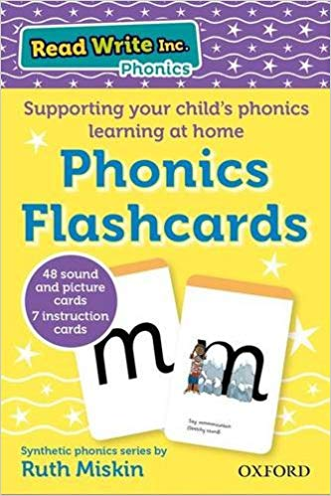 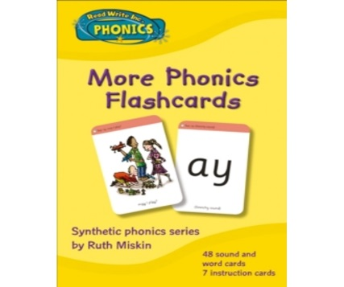

Set 1 Set 2 and Set 3

[www.oxfordowl.co.uk](http://www.oxfordowl.co.uk)

A great website that has lots of useful information on it to help you with supporting your son’s/daughter’s maths and reading development.

**Activities to do at home with your child**

You will need a pack of Set 1, 2 and 3 Speed Sound cards (see resources for home).

Practise Set 1 ‘speed sounds’ in the Spring Term (Year Reception). Practise Set 2 ‘speed sounds’ in the Summer Term (Year Reception) and practise Set 3, (Year 1) from Autumn Term onwards. Please continue to practise Set 2 sounds as well during year 1.

**How to practise Set 1 speed sounds**

When you practise your son’s/daughter’s Set 1 ‘speed sounds’, you either have to stretch or bounce it.

Example of how to practise the stretchy speed sound m (as in m-u-m)

• look at the picture side - stretch mmmm

• stretch the sound and say the phrase mmmountain

• repeat the phrase mmmmmmmmountain

• look at the letter side - say m as in mmm not muh

Example of how to practise the bouncy speed sound a (as in b-a-t)

• look at the picture side - bounce the sound and say a-a-a-a

• bounce the sound and say the phrase a-a-a-a, apple

• repeat the phrase a-a-a-a, apple

• look at the letter side - say a

**How to practise Set 2 speed sounds**

When you practise your son’s/daughter’s Set 2 ‘speed sounds’, you either have to stretch or bounce it.

Example of how to practise the stretchy speed sound ay (as in play)

• look at the picture side - stretch aaaaay

• stretch the sound and say the phrase aaaay, may I play?

• repeat the phrase ay, may I play?

• look at the letter side - say ay

• green words – encourage your son/daughter to ‘sound out’ and ‘sound blend’ the words containing the speed sound they have just practised e.g. t-r-ay tray

Example of how to practise the bouncy speed sound oo (as in b-oo-k)

• look at the picture side - bounce the sound and say oo-oo-oo

• bounce the sound and say the phrase oo-oo-oo, Look at a book

• repeat the phrase oo, Look at a book

• look at the letter side - say oo

• green words – encourage your son/daughter to ‘sound out’ and ‘sound blend’ words containing the speed sound they have just practised

**Using the green word lists**

• point to the sound as you ‘sound out’ each word e.g. p-l-ay or bl-ow. Be sure you don’t add an intrusive ‘uh’ to the end of consonant sounds. Say p not puh, s not suh etc

• repeat, getting faster each time

• in the end your son/daughter will be able to read them without sounding or blending

**Green words to practice at home**

Please do not practice all these words. Concentrate on one or two sounds at a time when practicing Set 2 words and when they know them, move on. **6 words a night is ample**. Encourage your son/daughter to highlight them when they can read them without sounding out.

**Set 1 words**

|  |  |  |  |  |  |
| --- | --- | --- | --- | --- | --- |
| **am** | **mad** | **sad** | **at** | **sat** | **mat** |

|  |  |  |  |  |  |
| --- | --- | --- | --- | --- | --- |
| **is** | **sit** | **pin** | **tin** | **and** | **cup** |

|  |  |  |  |  |  |
| --- | --- | --- | --- | --- | --- |
| **dig** | **pig** | **dog** | **cog** | **top** | **mop** |

|  |  |  |  |  |  |
| --- | --- | --- | --- | --- | --- |
| **pen** | **ten** | **let** | **pet** | **leg** | **peg** |

|  |  |  |  |  |  |
| --- | --- | --- | --- | --- | --- |
| **red** | **bed** | **yes** | **wet** | **job** | **not** |

|  |  |  |  |  |  |
| --- | --- | --- | --- | --- | --- |
| **cat** | **bat** | **rat** | **man** | **pan** | **fan** |

|  |  |  |  |  |  |
| --- | --- | --- | --- | --- | --- |
| **zip** | **quid** | **quick** | **fish** | **shop** | **rush** |

|  |  |  |  |  |  |
| --- | --- | --- | --- | --- | --- |
| **chip** | **chop** | **chin** | **thin** | **with** | **bath** |

|  |  |  |  |  |  |
| --- | --- | --- | --- | --- | --- |
| **rink** | **sink** | **wink** | **pink** | **sing** | **wing** |

|  |  |  |  |  |  |
| --- | --- | --- | --- | --- | --- |
| **long** | **song** | **off** | **huff** | **fizz** | **buzz** |

|  |  |  |  |  |  |
| --- | --- | --- | --- | --- | --- |
| **sock** | **rock** | **hiss** | **miss** | **pull** | **full** |

|  |  |  |  |  |  |
| --- | --- | --- | --- | --- | --- |
| **dress** | **click** | **hand** | **splash** | **thick** | **quack** |

**Set 2 words**

|  |  |  |  |  |  |
| --- | --- | --- | --- | --- | --- |
| **day** | **way** | **say** | **play** | **pray** | **spray** |

|  |  |  |  |  |  |
| --- | --- | --- | --- | --- | --- |
| **see** | **feet** | **been** | **week** | **sleep** | **green** |

|  |  |  |  |  |  |
| --- | --- | --- | --- | --- | --- |
| **high** | **night** | **light** | **right** | **might** | **fright** |

|  |  |  |  |  |  |
| --- | --- | --- | --- | --- | --- |
| **bow** | **snow** | **show** | **glow** | **flow** | **grow** |

|  |  |  |  |  |  |
| --- | --- | --- | --- | --- | --- |
| **too** | **zoo** | **mood** | **fool** | **roof** | **spoon** |

|  |  |  |  |  |  |
| --- | --- | --- | --- | --- | --- |
| **took** | **cook** | **book** | **foot** | **wool** | **shook** |

|  |  |  |  |  |  |
| --- | --- | --- | --- | --- | --- |
| **car** | **farm** | **star** | **park** | **start** | **sharp** |

|  |  |  |  |  |  |
| --- | --- | --- | --- | --- | --- |
| **born** | **sort** | **fork** | **worn** | **sport** | **horse** |

|  |  |  |  |  |  |
| --- | --- | --- | --- | --- | --- |
| **air** | **fair** | **hair** | **pair** | **chair** | **stair** |

|  |  |  |  |  |  |
| --- | --- | --- | --- | --- | --- |
| **girl** | **bird** | **dirt** | **stir** | **firm** | **whirl** |

|  |  |  |  |  |  |
| --- | --- | --- | --- | --- | --- |
| **out** | **loud** | **mouth** | **found** | **round** | **shout** |

|  |  |  |  |  |  |
| --- | --- | --- | --- | --- | --- |
| **toy** | **boy** | **joy** | **alloy** | **annoy** | **enjoy** |

**Set 3**

How to practise Set 3 speed sounds:

Remember, **only** practise Set 3 speed sounds once your son’s/ daughter’s knowledge of the Set 2 ‘speed sounds’ is secure. Your son/daughter should know all the Set 2 sounds and the letters that represent them without having to rely on the picture prompt.

Example of how to practise Set 3 ‘speed sounds’

• Review the similar sound from the Set 2 cards e.g. show the *ee*, what can you see speed card say – *ee* sound

• Hold up the letter side of the new speed sound e.g. show the *ea* letter card say – *ea* ask your son/daughter to repeat the sound *ea*

• Hold up the picture side of the speed sound card e.g. say the phrase *ea, cup of tea.* Repeat

• Show your child both sides of the card your son/daughter must say either *ea* or *ea, cup of tea* depending on which side you show

Some cards have three different spellings e.g. *ir in bird, ur in burn*, and *er in fern*. It is important you do not introduce all the sounds together for the first time. For the *ir* ‘speed sound’, practise *ir* and *ur* first and then practise *er*.

Practise the Set 3 speed sounds in these groups. Those in bold are from Set 3, those not in bold, your son/daughter will have learnt in Set 2.

ay, **ai** and **a-e**

ee, **ea** and **e-e**

igh, **ie** and **i-e**

ow, **oa** and **o-e** (as in home)

oo, **ue** and **u-e** (as in huge)

or, **aw** and **au**

air and **are**

ir, **ur** and **er**

ou and **ow**

oy and **oi**

**ire**

**ear**

**ure**

**tion**

**cious/tious**

**Set 3 Words**

Please do not practice all these words until your son/daughter knows all their Set 2 sounds and can read many of the Set 2 words without sounding out. Concentrate on one sound at a time(e.g.ee/ea) and when they know it, move on. **6 words a night is ample**. Encourage your child to highlight them when they can read them without sounding.

|  |  |  |  |  |  |
| --- | --- | --- | --- | --- | --- |
| **eat** | **tea** | **need** | **dream** | **seat** | **sleep** |

|  |  |  |  |  |  |
| --- | --- | --- | --- | --- | --- |
| **join** | **toy** | **voice** | **choice** | **noise** | **enjoy** |

|  |  |  |  |  |  |
| --- | --- | --- | --- | --- | --- |
| **make** | **shake** | **play** | **name** | **brave** | **tray** |

|  |  |  |  |  |  |
| --- | --- | --- | --- | --- | --- |
| **street** | **Pete** | **scream** | **Steve** | **green** | **compete** |

|  |  |  |  |  |  |
| --- | --- | --- | --- | --- | --- |
| **shine** | **white** | **light** | **smile** | **like** | **night** |

|  |  |  |  |  |  |
| --- | --- | --- | --- | --- | --- |
| **home** | **know** | **rose** | **spoke** | **stole** | **glow** |

|  |  |  |  |  |  |
| --- | --- | --- | --- | --- | --- |
| **rude** | **mood** | **brute** | **moon** | **flute** | **excuse** |

|  |  |  |  |  |  |
| --- | --- | --- | --- | --- | --- |
| **saw** | **short** | **straw** | **dawn** | **horse** | **claw** |

|  |  |  |  |  |  |
| --- | --- | --- | --- | --- | --- |
| **care** | **share** | **stair** | **flare** | **square** | **software** |

|  |  |  |  |  |  |
| --- | --- | --- | --- | --- | --- |
| **turn** | **slurp** | **third** | **hurl** | **purse** | **whirl** |

|  |  |  |  |  |  |
| --- | --- | --- | --- | --- | --- |
| **over** | **turn** | **better** | **runner** | **bird** | **corner** |

|  |  |  |  |  |  |
| --- | --- | --- | --- | --- | --- |
| **howl** | **shout** | **down** | **flower** | **crowd** | **found** |

|  |  |  |  |  |  |
| --- | --- | --- | --- | --- | --- |
| **paid** | **snail** | **wake** | **drain** | **play** | **stain** |

|  |  |  |  |  |  |
| --- | --- | --- | --- | --- | --- |
| **toad** | **oak** | **home** | **cloak** | **toast** | **glow** |

|  |  |  |  |  |  |
| --- | --- | --- | --- | --- | --- |
| **new** | **blew** | **too** | **drew** | **spoon** | **grew** |

|  |  |  |  |  |  |
| --- | --- | --- | --- | --- | --- |
| **tie** | **pie** | **dries** | **cried** | **tries** | **lied** |

|  |  |  |  |  |  |
| --- | --- | --- | --- | --- | --- |
| **Paul** | **haunt** | **launch** | **jaunt** | **Laura** | **astronaut** |

|  |  |  |  |  |  |
| --- | --- | --- | --- | --- | --- |
| **cue** | **glue** | **blue** | **true** | **tissue** | **rescue** |

|  |  |  |  |  |  |
| --- | --- | --- | --- | --- | --- |
| **phone** | **phonics** | **graph** | **nephew** | **Phillip** | **telephone** |

|  |  |  |  |  |  |
| --- | --- | --- | --- | --- | --- |
| **whip** | **wheel** | **when** | **whirl** | **whisk** | **whisper** |

|  |  |  |  |  |  |
| --- | --- | --- | --- | --- | --- |
| **fire** | **hire** | **wire** | **bonfire** | **inspire** | **conspire** |

|  |  |  |  |  |  |
| --- | --- | --- | --- | --- | --- |
| **ear** | **hear** | **dear** | **fear** | **near** | **year** |

|  |  |  |  |  |  |
| --- | --- | --- | --- | --- | --- |
| **sure** | **pure** | **cure** | **picture** | **creature** | **adventure** |

|  |  |  |
| --- | --- | --- |
| **tradition** | **congratulations** | **attention** |

|  |  |  |
| --- | --- | --- |
| **conversation** | **celebration** | **exploration** |

|  |  |  |
| --- | --- | --- |
| **scrumptious** | **ferocious** | **vicious** |

|  |  |  |  |  |
| --- | --- | --- | --- | --- |
| **he** | **We** | **me** | **she** | **be** |

**The Year 1 Phonics Screening Check**

The phonics screening check will be taken individually by all children in Year 1, in England, during a week in June. It is designed to give teachers and parents, information on how your son/daughter is progressing in phonics.

**What is the phonic screening check?**

There will be two sections in this 40-word check and it will assess phonics skills and knowledge learnt through Reception and Year 1.

**What will it check?**

It will check that your son/daughter can:

• Sound out and blend sounds in order to read simple words.

• Read phonically decodable one-syllable and two-syllable words, e.g. cat, sand, windmill.

• Read a selection of nonsense words which are referred to as pseudo words.

**What are nonsense or pseudo words and why are they included?**

These are words that are phonically *decodable* but are not actual words with an associated meaning e.g. brip, snorb. Pseudo words are included in the check specifically to assess whether your son/daughter can *decode* a word using phonics skills and not their memory.

The pseudo words will be shown to your son/daughter with a picture of a monster and they will be asked to tell their teacher what sort of monster it is by reading the word. This not only makes the check a bit more fun, but provides the children with a context for the nonsense word which is independent from any existing vocabulary they may have. Crucially, it does not provide any clues, so your son/daughter just has to be able to *decode* it.

**Is there a pass mark?**

The government set a benchmark figure to indicate a pass or fail check. However, the check is not about passing or failing but checking appropriate progress is being made. Children progress at different speeds so not reaching the threshold score does not necessarily mean there is a serious problem. Your son/daughter will re-sit the check the following summer term in Year 2, having had some Read, Write, Inc support during year 2 to address gaps.

**What happens to the results?**

The school will report your son’s/daughter’s results to you by the end of the Year 1 summer term as well as to the local authority. This will be the same for any children who re-take the phonics screening check in Year 2. If you have any concerns, do talk to your teacher about this in a parents’ meeting or after school.

More information can be found on [www.oxfordowl.co.uk](http://www.oxfordowl.co.uk)

**Useful websites**

<http://www.oxfordowl.co.uk/question/index/3> - Has lots of information and guidance for parents/carers

<http://www.phonicsplay.co.uk/ParentsMenu.htm> - Offers a selection of interactive games for all phonic phases. Mostly simple games.

<http://www.ictgames.com/literacy.html> - Has a great selection of games that link well with games in Letters and Sounds.

<http://www.phonicsinternational.com/hear_the_sounds/hear_the_sounds_1.htm> - Useful page which demonstrates pronunciation of all sounds.

<https://www.topmarks.co.uk/english-games/5-7-years/letters-and-sounds> - Offers a selection of interactive games for all phonic phases.

<https://www.phonicsbloom.com/> - Offers a selection of interactive games for all phonic phases.

<http://www.familylearning.org.uk/phonics_games.html> - Offers links to a selection of phonics games.

<https://www.education.com/games/phonological-awareness/> - Offers a selection of interactive games for all phonic phases.