Maths Together

20 number games
to play

Key Stage 1
Pick a pair

You will need
- Pack of playing cards - select a number of matching pairs of cards appropriate to your child.

How to play
Shuffle, and spread all the cards out face down on the table between the players (you can either choose a random arrangement, or lay the cards out in grid form; the latter makes it easier to remember where cards are placed).

The object of the game is to find matching pairs. Players take it in turns to turn over 2 cards. Let both the players see them and study them. If they are not a matching pair, try to remember what and where they are, then turn them back over. Play then passes to the next player. If they are a matching pair, that player removes them from the table and keeps them, and then has another turn.
When all cards have been removed from the table, each player counts up the number of cards they have collected. The player with the most cards is the winner.

Step up the challenge
Use more pairs of cards – up to the whole pack of 52!

Three or more

You will need
- Five dice

How to play
Players in turn roll all five dice and score for three-of-a-kind or better. If a player only has two-of-a-kind they may re-throw the remaining dice in an attempt to improve the matching dice values. If no matching numbers are rolled a player scores 0.

Players score the following number of points accordingly.
3-of-a-kind: 3 points
4-of-a-kind: 6 points
5-of-a-kind: 12 points

A set number of rounds are played (say 5) and the player with the highest score at the end of a game, is the winner.
Fairy tale castles
Jack in the box
Six dwarves
You will need
- 1 die
- One of the game boards on the next few pages

How to play
Each player takes it in turns to roll a dice. They then place their counter on the picture with that number.

Give each player a stack of coloured counters. Players take it in turns to roll a dice, and place one of their counters on the picture with the corresponding number, then pass the die to the next player. If there is already a counter on the appropriate picture, you miss your go. When all the pictures are covered, count up the counters. Whoever has placed the most counters is the winner.

Step up the challenge
Create your own game together by writing the numbers (digits or words) on your own pictures. Or play be writing in the number digits or words.

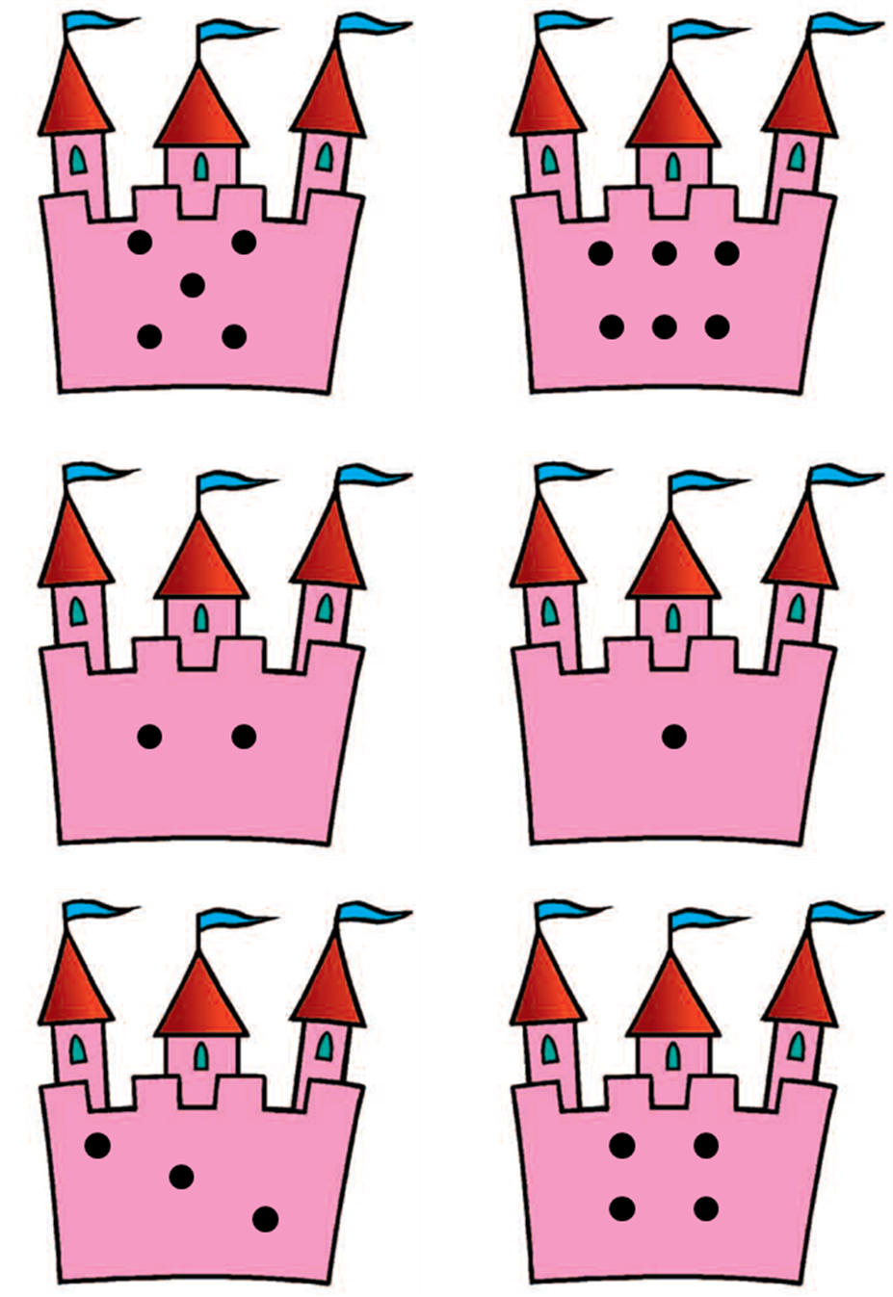
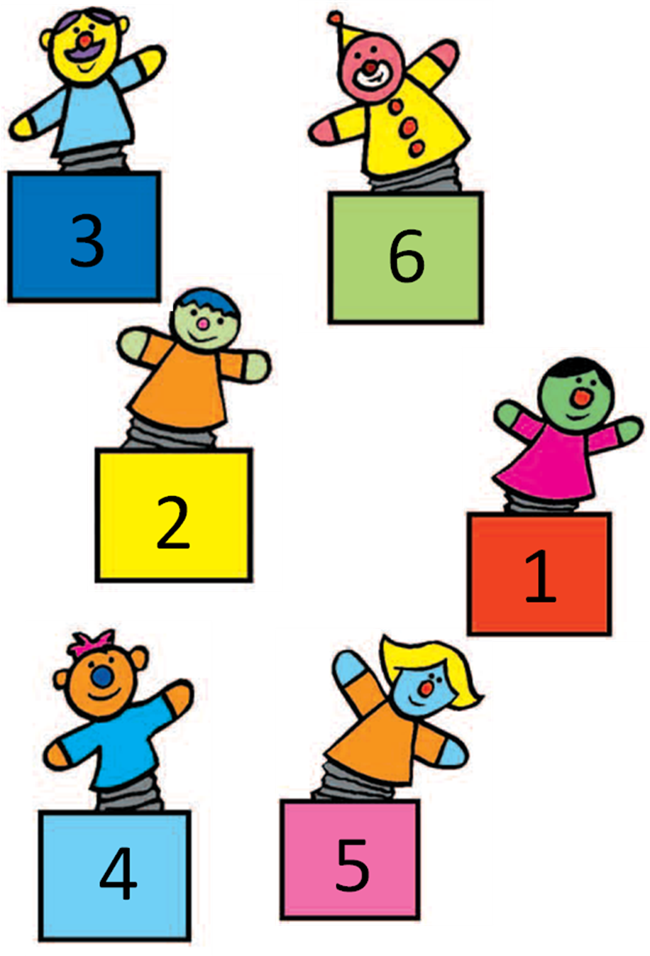
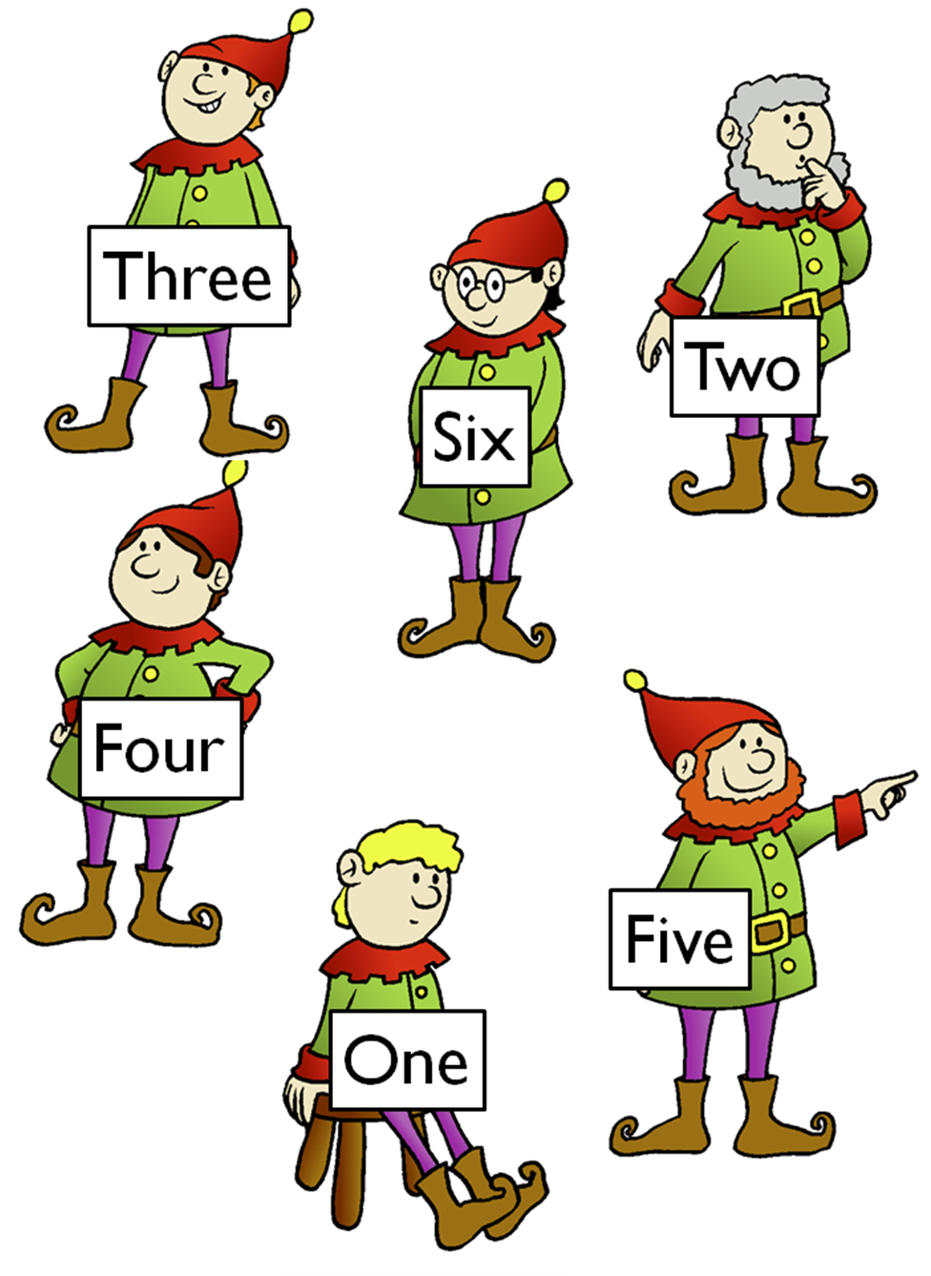
Mouse!

You will need
- 1 die
- Pencil and paper

How to play
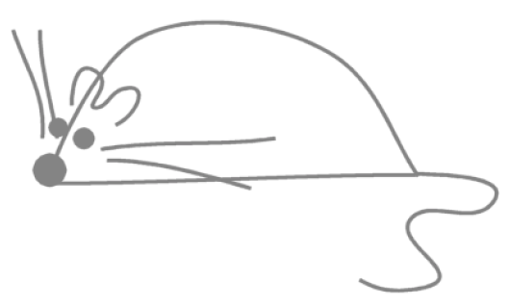
The aim of the game is to be the first to complete a Mouse. Each roll of the die enables a particular body part to be drawn as follows:
6 = body
5 = nose
4 = whiskers
3 = eyes
2 - ears
1 = tail

The body must be drawn before the other body parts are added to it, so players must therefore roll a 6 to start. Once the body has been drawn, the other parts of the mouse may be added in any order. If you roll a number which relates to a part you have already added, you miss your go and pass the die on.

Step up the challenge
Use 2 dice. After each roll, add the two to determine the total. For this version, players must roll a 12 to draw the body, 10 for the nose, eight for whiskers, six for eyes, four for ears and two for the tail.
Three or more

You will need
- 5 dice
- Pencil and paper to keep score

How to play
Players in turn roll all five dice and score for three-of-a-kind or better. If a player only has two-of-a-kind they may re-throw the remaining dice in an attempt to improve the matching dice values. If no matching numbers are rolled a player scores 0.

Players score the following number of points accordingly.
3-of-a-kind: 3 points
4-of-a-kind: 6 points
5-of-a-kind: 12 points

A set number of rounds are played (say 5) and the player with the highest score at the end of a game, is the winner.

Farmyard

The more hands-on practice young children have with counting, the easier it becomes to visualize numbers and give meaning to them. This farmyard game makes early learning fun! If you don’t have farm animals, use dinosaurs, cars, or anything else you have to hand, or print out our animal counters.

You will need
- 1 die
- Toy farm animals

How to play
Put the animals in the center of the table where everyone can reach them. Draw a field per player.

Each player rolls the die and selects the appropriate number of animals to go into his field.

The first child to 20 wins. Encourage lots of counting along the way and ask plenty of questions (“How many more animals will Mary need to get to 20?”).

Challenge me!
Turn the game round and start with 20 animals in a field.
Board games

You will need
- A counter per player
- A die
- A game board (e.g. the one overleaf)

There are lots of great board games out there. Do not feel restricted to these ones!

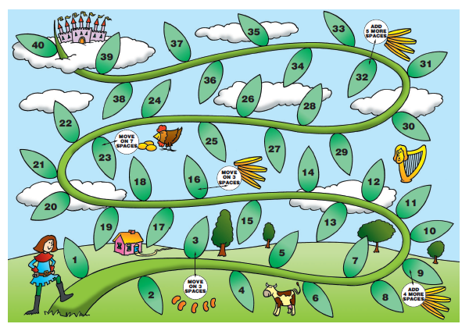

Track games

Make a number track to 20, or longer. Make it relevant to your child’s interests – sea world, space, monsters… Then play games on it.

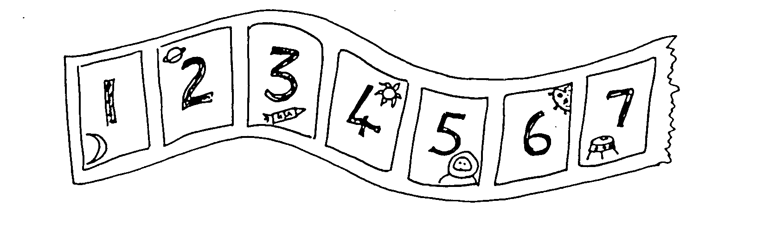
- Throw a dice. Move along that number of spaces. BUT before you move, you must work out what number you will land on. If you are wrong, you don’t move! The winner is the first to land exactly on 20. Now play going backwards to 1.
- Throw a dice. Find a number on the track that goes with the number thrown to make either 10 or 20. Put a counter on it, e.g. you throw a ‘4’ and put a counter on either 6 or 16. If someone else’s counter is there already, you may replace it with yours! The winner is the first person to have a counter on 8 different numbers.

Secret numbers

You will need
- Pencil and paper

How to play

Write the numbers 0 to 20 on a sheet of paper.

Ask your child secretly to choose a number on the paper. Then ask him / her some questions to find out what the secret number is, e.g.
  - Is it less than 10?
  - Is it between 10 and 20?
  - Does it have a 5 in it?
He / she may answer only yes or no.
Once you have guessed the number, it is your turn to choose a number. Your child asks the questions.

For an easier game, use numbers up to 10.

Step up the challenge
For a harder game, use only 5 questions, or use bigger numbers (up to 100).
War

You will need
Standard deck of 52 cards (you may want to remove the picture cards)

How to play
To start, the cards are dealt to the players and kept face-down. Neither player must look at their cards.
Then, both players turn over the top card in their piles and put them face-up in the centre, next to the other player’s card. Whoever has turned over the higher ranking card, never mind which suit it is of, takes up both cards and adds them to the bottom of his pile.
This then continues until two cards of the same value (eg 2 fours) are placed down together. This constitutes “War”. Both players then take two more cards and put one face-down on top of the card they have already placed in the middle, and one face-up. Whoever puts down the higher ranking face-up card wins all six.
If, of course, two more same-ranking cards are put down, the state of “War” continues until there is a winner.
The game is won by the player who manages to collect all the cards.
Another description of ‘war’

Basic War—Each player turns one card face up. The player with the greatest number wins the skirmish, placing his own and all captured cards into his prisoner pile. Whenever there is a tie for greatest card, all the players battle: each player lays three cards face down, then a new card face up. The greatest of these new cards will capture everything on the table. Because all players join in, someone who had a low card in the initial skirmish may ultimately win the battle. If there is no greatest card this time, repeat the 3-down-1-up battle pattern until someone breaks the tie. The player who wins the battle captures all the cards played in that turn.

Endgame
When the players have fought their way through the entire deck, count the prisoners. Whoever has captured the most cards wins the game. Or shuffle the prisoner piles and play on until someone collects such a huge pile of cards that the others concede.

Variations
For most variations, the basic 3-down-1-up battle pattern becomes 2-down-2-up. For advanced games, however, the battle pattern is different: in case of a tie, the cards are placed in a center pile. The next hand is played normally, with no cards turned down, and the winner of that skirmish takes the center pile as well.
Addition War—Players turn up two cards for each skirmish. The highest sum wins.
Subtraction War—Players turn up two cards and subtract the smaller number from the larger. This time, the greatest difference wins the skirmish.

Sevens

You will need
- Standard 52-card deck

How to play
The entire pack of cards is dealt clockwise and face-down around the group.

The players then sort their cards into sequences in each suit. The player who holds the 7 of diamonds starts by placing this card down in the centre. The game then continues clockwise, with each player, if they can, adding a diamond card to the sequence. This can either go up (8, then 9, then 10 etc) or down (6, then 5, then 4 etc). Any cards played are placed on either side of the 7, as appropriate, so that the diamonds form a row. A player can also start a new sequence in a different suit by placing any of the other 7s below the 7 of diamonds so that a new row can be built in that suit. If a player can do neither, they simply skip a turn.

The winner is the first player to use up all his cards, although if you wish you can continue to play until all the cards have been used up and all four rows are complete.
Beat that!

You will need
- 2 dice

How to play
Roll the dice and put them in order to make the highest number possible. If you roll a 4 and an 6, for example, your best answer would be 64. Write down your answer, pass the dice, and challenge the next player to “Beat That!”

Play in rounds and assign a winner to each round.

For a change, try making the smallest number possible! This is a great game for reinforcing the concept of place value. If you are playing with younger children, explain your reasoning out loud and encourage them to do the same.

One. two, three – show me!

On the count of 3, the players throw their fist out in front of them with anything from 0 fingers to 5 fingers extended. At the same time, one player (take it in turns) calls out a number. If the fingers extended add up to that number, the player wins.

Obviously, the player must call out a number which might come up. So with 2 players, the numbers can be between 0 and 10. Players must be careful to throw their fists on time, too, so that no one can be accused of changing their fingers after the number is called!
Players will soon learn that if they are displaying zero fingers themselves they should call low, etc.

Takings

For this game you will need a dice and a collection of small things such as Lego bricks, sticky shapes or dried beans. You will also need pencil and paper.

Take turns.

Roll a dice. Take that number of beans. Write down the number.

Keep rolling the dice and taking that number of beans. BUT, before you take them, you must write down your new total.

For example, Sally has 7. She throws 4. She has to work out how many she will have now. She starts counting from seven: eight, nine, ten, eleven. She writes 11.

You can only take your beans if you are right.

The first person to collect 20 beans wins!

Dicey circles

You will need
- 1 die
- pencil and paper

How to play
- Each of you should draw four circles on your piece of paper. Write a different number between 2 and 12 in each circle.
2
6
8
9

- Roll the dice twice. Add the two numbers.
- If the total is one of the numbers in your circles then you may cross it out.
- The first person to cross out all four circles wins.
Greatest sum

You will need
- 2 dice
- 10 counters or toys – the winning player is the one with the most of these when all have gone.

How to play
Roll both and add – greatest sum wins
The winning player takes one the toys. Rather than using counters, find a collection of 10 small toys which are close to your child’s heart and rename the game to match.

Step up the challenge
Greatest difference
2 dice
Roll both and find the difference – greatest difference wins
Going to Boston
You will need
- 3 dice
- Pencil and paper

How to play
Roll the dice and keep the highest. Roll the remaining dice and again set aside the highest. Roll the last die, and add up your total. Write down your score.

How to play
Each player in turn has three throws of the dice. On the first throw the highest number is put to one side. If two or more dice show the highest number only one is kept. The remaining two dice are thrown again and the highest is put aside once more. The final die is rolled and the total of all three is the player's score. The player with the highest score, after each player has had a turn, wins that round. A set number of rounds are played and the player who takes the most is the overall winner.

Dice game

You will need

1 die

paper and pencil

How to play
- Take turns.
- Choose a number between 1 and 10 and write it down.
- Throw the dice and say the dice number.
- Work out the difference between the chosen number and the dice number, e.g. if you wrote down a 2 and the dice shows 5, the difference is 3.

You could also draw a number line to help your child to see the difference between the two numbers.

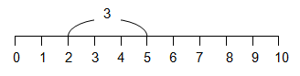

Sum and difference

You will need
- Pencil and paper

This game is from Nrich

How to play
Start by drawing a number line from 0 to 20 like this:
The first player chooses a number on the line and crosses it out.
The same player then chooses a second number and crosses that out too.
Finally, he or she circles the sum or difference of the two numbers and writes down the calculation.
For example, the first player's go could look like this:
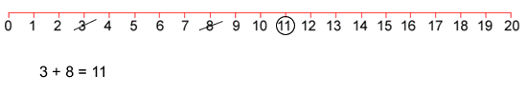
The second player must start by crossing off the number that player 1 has just circled.
He or she then chooses another number to cross out and then circles a third number which is the sum or difference of the two crossed-off numbers.
Player 2 also writes down their calculation.
For example, once the second player has had a turn, the game could look like this:
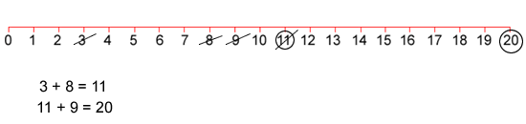
Play continues in this way with each player starting with the number that has just been circled.
For example, player one could then have a turn which left the game looking like this:
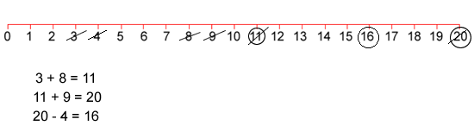
The winner of the game is the player who stops their opponent from being able to go.

Totality

You will need
- Totality game board
- A counter

The first player names a 'score' and this is the total that both players try to reach.

The second player places a counter on the board over one of the numbers and says that number.

The first player moves the same counter in any direction along a line segment to a neighbouring number and announces the total of the two numbers.

The second player moves the same counter to cover a neighbouring number, adds on that number, and announces the total of the three numbers.

The players take it in turns to slide the counter to cover a neighbouring number and to add that number to the total. The players must move when it is their turn and no 'jumping' is allowed.

The winner is the player who makes the total to be exactly equal to the 'score' declared at the start. Making the total go above the 'score' loses the game.

With thanks to Nrich.
The game can be found online at http://nrich.maths.org/1216

